**Lab-07**

**OBJECTIVE:** To Understand Multithreading .

**Task:** Write the same code for matrix multiplication and divide the code into ten threads. Also note the timestamp at the start and end of the program. Give your conclusion.

**Simple Matrix Multiplication with main thread.**

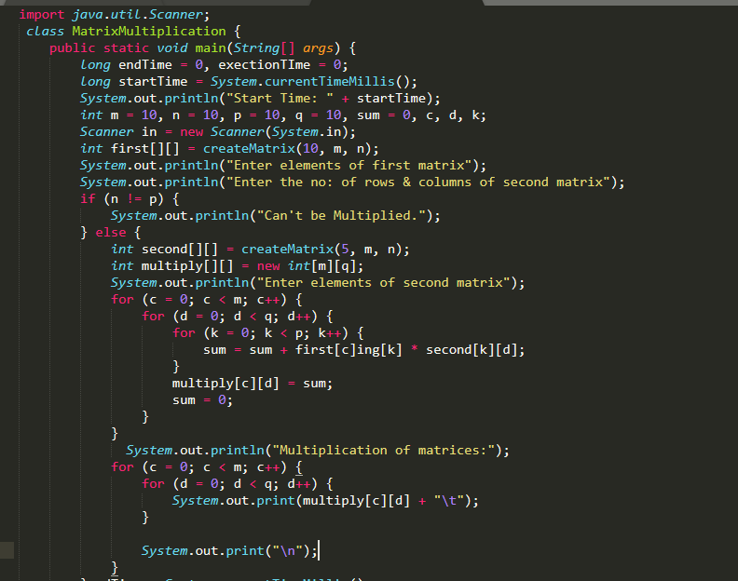

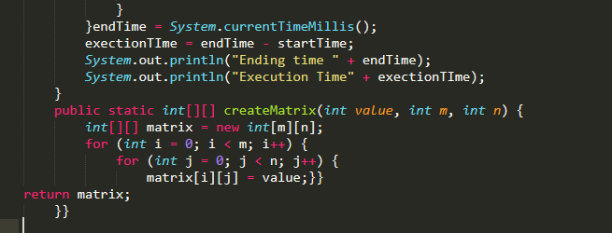

**Output:**

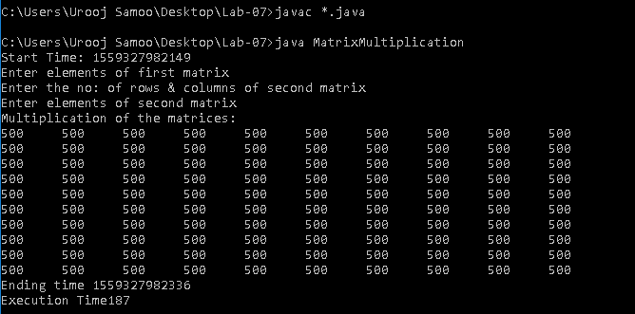

**Matrix Multiplication with Multiple Threads**

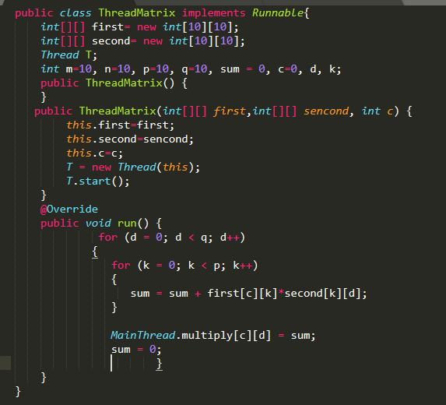

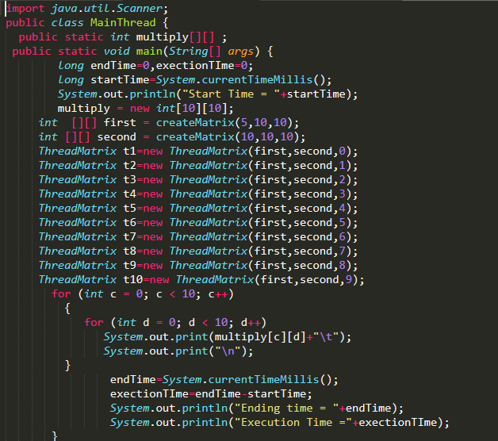

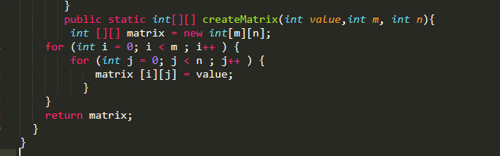

**Output:**

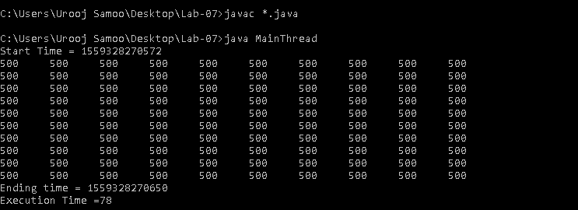

**Result:** We have observe that without threads it requires

execution time 187 milliseconds and with threads it requires execution time 87 milliseconds.

**Synchronization-Task:**

**Before Synchronization:**

**Table.java**

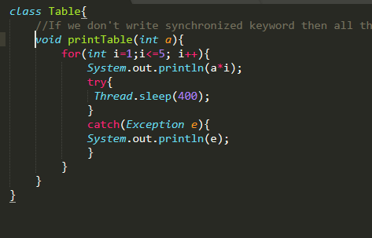

**Thread1**

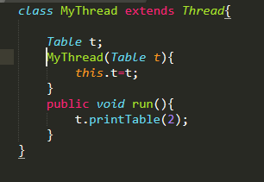

**Thread2**

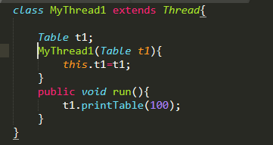

**Main Class**

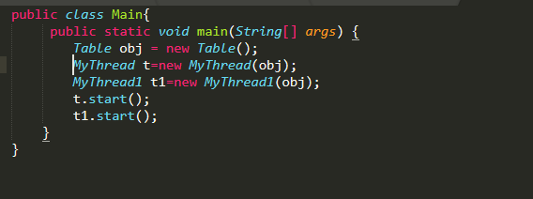

**Output**

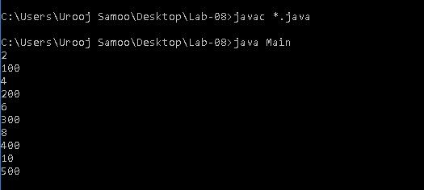

**After Synchronization:**

**Table.java**

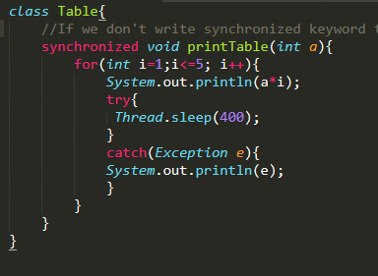

**Thread1**



**Thread2**



**Main Class**



**Output**

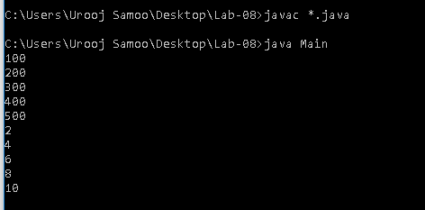

**Result:** We have observed that if we don’t write synchronized keyword then all the threads are working together.But if we write synchronized keyword then both threads working one by one it means 1st thread work completely and then thread starts